CSCI 5980/8980: Spatial Enabled Artificial Intelligence
Assignment 1 (10 points)
Due Date: 2022/02/15 11:59:00 CST

1. Overview of the Assignment
With this assignment, you will learn to use existing spatial data to prepare feature vectors capturing geographic context to support spatial artificial intelligence tasks. You will use PostgreSQL with PostGIS and Apache Sedona (formerly GeoSpark) to perform spatial queries. You will compare their performance in terms of query efficiency using the same query tasks on both platforms. You can access the data and sample code on Google Drive.

2. Programming Requirements and Environment Settings
- You must use SQL and Python to implement all tasks.
- Programming Environment:
- JAVA version 1.8, Python 3.7, Pyspark 3.0.0, Sedona 1.1.1
- [Optional] You can use Conda to manage your programming environment.
$conda create --name [ENV] -y python=3.7
$conda activate [ENV]
$conda install -c conda-forge gdal==3.4.0
$conda install -c conda-forge pyspark==3.0.0
$pip install apache-sedona
Sedona Python requires two additional jar packages, sedona-python-adapter and geotools-wrapper, to work properly. Specifically, you need to put two jar packages under [YOUR PYTHON PATH]/site-packages/pyspark/jar/.

3. Assignment Datasets
This assignment will use two types of datasets.
- Two sampled datasets of air quality sensor locations [download]
These datasets contain sensor IDs and locations (longitude and latitude in WGS84). One dataset contains more than 400 locations, and the other dataset has 10 locations. Both datasets are sampled PurpleAir sensor locations in California.
- OpenStreetMap (OSM) data [download]
OpenStreetMap (OSM) is a crowd-sourced worldwide map dataset. This assignment will use OSM data as a proxy to describe geographic context of air quality sensor locations. You need to download the file [.osm.pbf] of California (see the screenshot below), which is a compressed file of the OSM California data.
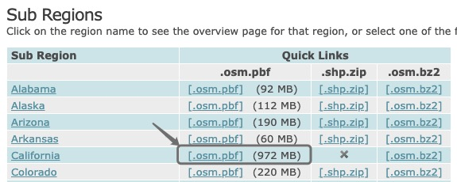

4. Deliverables and Tasks
You need to turn in a zip file, named as [your_login_id]_assignment1.zip (all lowercase), e.g., lin00786_assignment1.zip, containing the following files:
- [REQUIRED] Code scripts: one SQL script named as main.sql, one Python script named as main.py
We provide skeletons of the two scripts in [main.sql] and [main.py], and you will complete the required code block.
The SQL script will be graded manually. The Python script will be automatically graded by running
$python main.py --input_file [INPUT FILE] --osm_table [OSM TABLE] --out_path [OUT PATH]
- [REQUIRED] A result file named as geographic_features.csv
- [REQUIRED] A readme document in Word describing the results, named as readme.docx
- [OPTIONAL] You can include other Python scripts to support your programs (e.g., callable functions).

4.1. Task: Importing OSM data to PostgreSQL (PostGIS)
You need to import the OSM data (i.e., california-latest.osm.pbf) to PostgreSQL using the ogr2ogr tool and re-organize the imported tables for later use. Here are the steps:
- Download and install PostgreSQL (and the PostGIS extension) on your machine (see some installation screenshots in Appendix 1). Then you can create your own localhost server and database in PostgreSQL for this assignment. You can use PgAdmin to access and manage your PostgreSQL instance (Postico is recommended but only works for MacOS). You need to add the PostGIS extension by running CREATE EXTENSION postgis.
- Install GDAL and verify if ogr2ogr works by running $ogr2ogr. You will see the following screenshot if it succeeds.
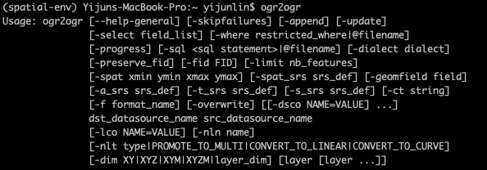
- Use ogr2ogr in GDAL to import the pbf file into PostgreSQL by running the following command (it will take a few minutes):
You will see five tables (e.g., lines) imported in your database if it succeeds.
- You will use these tables to create three new tables (named as line_features, polygon_features, and point_features) for later use. The SQL queries has been provided for you in osm.sql. If you are interested, we use gen_SQL_cmd.py to generate these SQL queries. You can also modify gen_SQL_cmd.py to generate your own queries for later assignments (e.g., modifying selected geo-features). The goal is to select some representative geo-features for each geometry type (points, lines, polygons). You can simply copy/paste and run the SQL queries in osm.sql in your PgAdmin (this step is time-consuming, taking around 20 minutes on a 2017 MacBook Pro).
- The SQL queries in osm.sql will generate tables with five columns (see the screenshot below). The geo_feature column describes the original categories in OSM data (e.g., highway and waterway). The feature_type column describes the subclass of these categories. For example, highway can be primary, motorway, residential, etc.
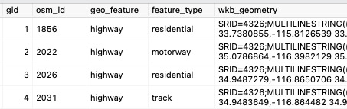

4.2. Task: Creating spatial buffers for air quality sensor locations (3 points)
You will create spatial buffers with varying sizes using the ST_Buffer function. We will use spatial buffers with radii of 100, 500, and 1,000 meters in this assignment.
- Note that the given locations are in “epsg:4326”, so you need to transform their geometries to a coordinate system with a meter unit.
- You need to implement this task using BOTH PostgreSQL (section 4.2.1) and Apache Sedona (section 4.2.2).

4.2.1. (1 point) Using PostgreSQL to create buffers. Here are the steps:
- Create a location table with the following schema:
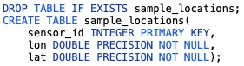
- Import the sampled datasets of air quality sensor locations (from section 3.a)
- Create a table with the following schema:
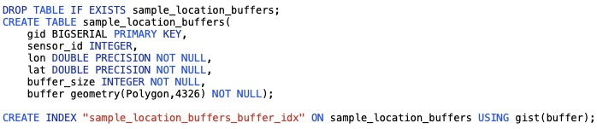
- Compute and insert the buffers of size 100, 500 and 1,000 meters to the table

4.2.2. (2 points) Using GeoSpark to create buffers
- Complete the gen_buffers function in main.py
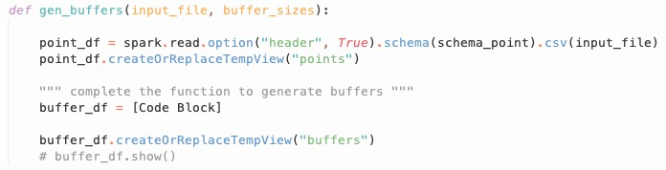

4.3. Task: Computing geographic features (5 points)
You will compute feature vectors capturing geographic features by spatially joining the created buffers from Task 4.2 and the OSM tables generated from Task 4.1.
- Specifically, you need to join the geometries of the created buffers and OSM data to calculate the aggregated number/length/area of the OSM geographic features within each buffer. For example, if the geometry type is “MultiPolygon”, the aggregation should be the summation of area sizes of all OSM geographic features within a buffer. You should use “meter” or “square meter” as your spatial units. For example, the left figure below shows a 200-meter buffer at Location A. The buffer intersects with five geographic features. The table below shows the desired output with the aggregated geographic features.
- You need to implement this task using BOTH PostgreSQL (section 4.3.1) and Apache Sedona (section 4.3.2).

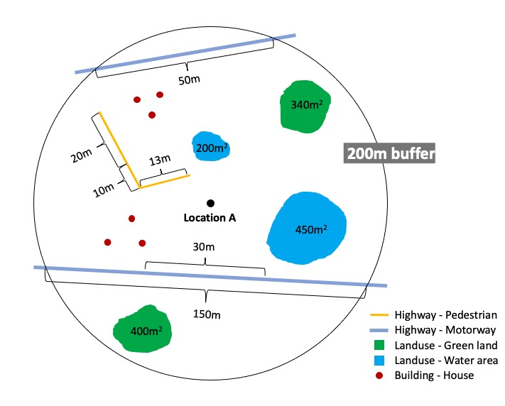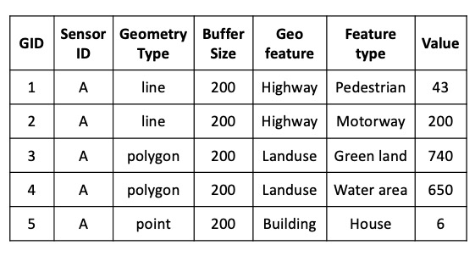

4.3.1. (1 point) Using PostgreSQL to compute geographic features
- Create a table with the following schema:
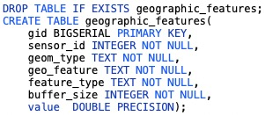
- Compute and insert all generated geographic features into the table. You need to write the SQL queries for line, polygon, and line features separately.

4.3.2. (4 points) Using GeoSpark to compute geographic features
- Load the OSM tables from PostgreSQL into Spark DataFrame. We provide an example solution in main.py using pandas. To use the example solution, you need to create an .env file using the same format as env_example and add the database connection configuration (e.g., username and password). You need to describe your own method in the readme document if you choose not to use the example solution.
- Complete the gen_geographic_features function in main.py. You need to call this function three times on the three OSM tables (polygon, line, and point features) generated from Task 4.1. Each call will generate a folder containing a CSV file by using the function [.coaleasce(1).write.csv()] in main.py. You will report the running time for each call.
- After running your scripts for the three tables (polygon, line, and point features), you need to merge the outputs of polygon, line, and point features to geographic_features.csv with the same schema in section 4.2.1. We provide merge.py for this purpose.
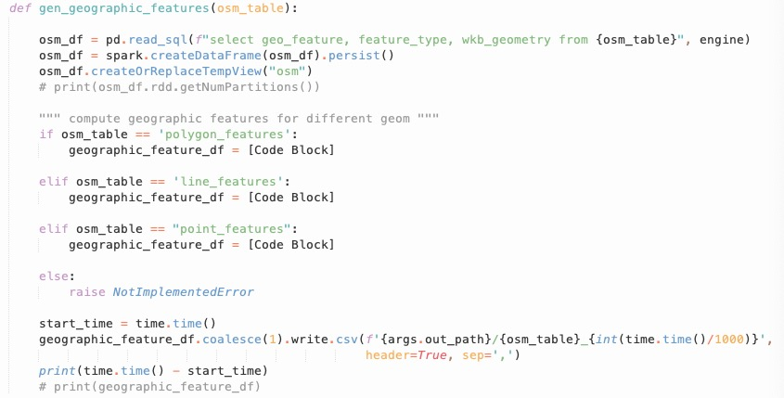

5. Grading criteria
- Your code should be runnable and be able to generate results correctly (that is, generating tables with the submitted SQL queries and generating geographic_features.csv with the submitted Python scripts successfully) to receive full points on Task 4.2 and Task 4.3 (a total of 8 points).
The SQL script will be graded manually. The Python code will be automatically graded by running
$python main.py --input_file [INPUT FILE] --osm_table line_features --out_path [OUT PATH]
$python main.py --input_file [INPUT FILE] --osm_table point_features --out_path [OUT PATH]
$python main.py --input_file [INPUT FILE] --osm_table polygon_features --out_path [OUT PATH]
$python merge.py
- In the readme document, you should report the running time of completing Task 4.3 on each OSM table by testing different location datasets as the input file in a table below (1 point). You need to explain the comparison results in several sentences (no more than 300 words) (1 point).
 |  | #locations = 400 | #locations = 10
PostgreSQL | Line
 | Polygon
 | Point
Apache Sedona | Line
 | Polygon
 | Point
Table: Time comparison using PostgreSQL and Apache Sedona
c. You can put any external libraries that are necessary to execute your code or other instructions that can help TA run your assignment.
Appendix
1. PostGIS extension installation via Stack Builder (you should see the following steps)
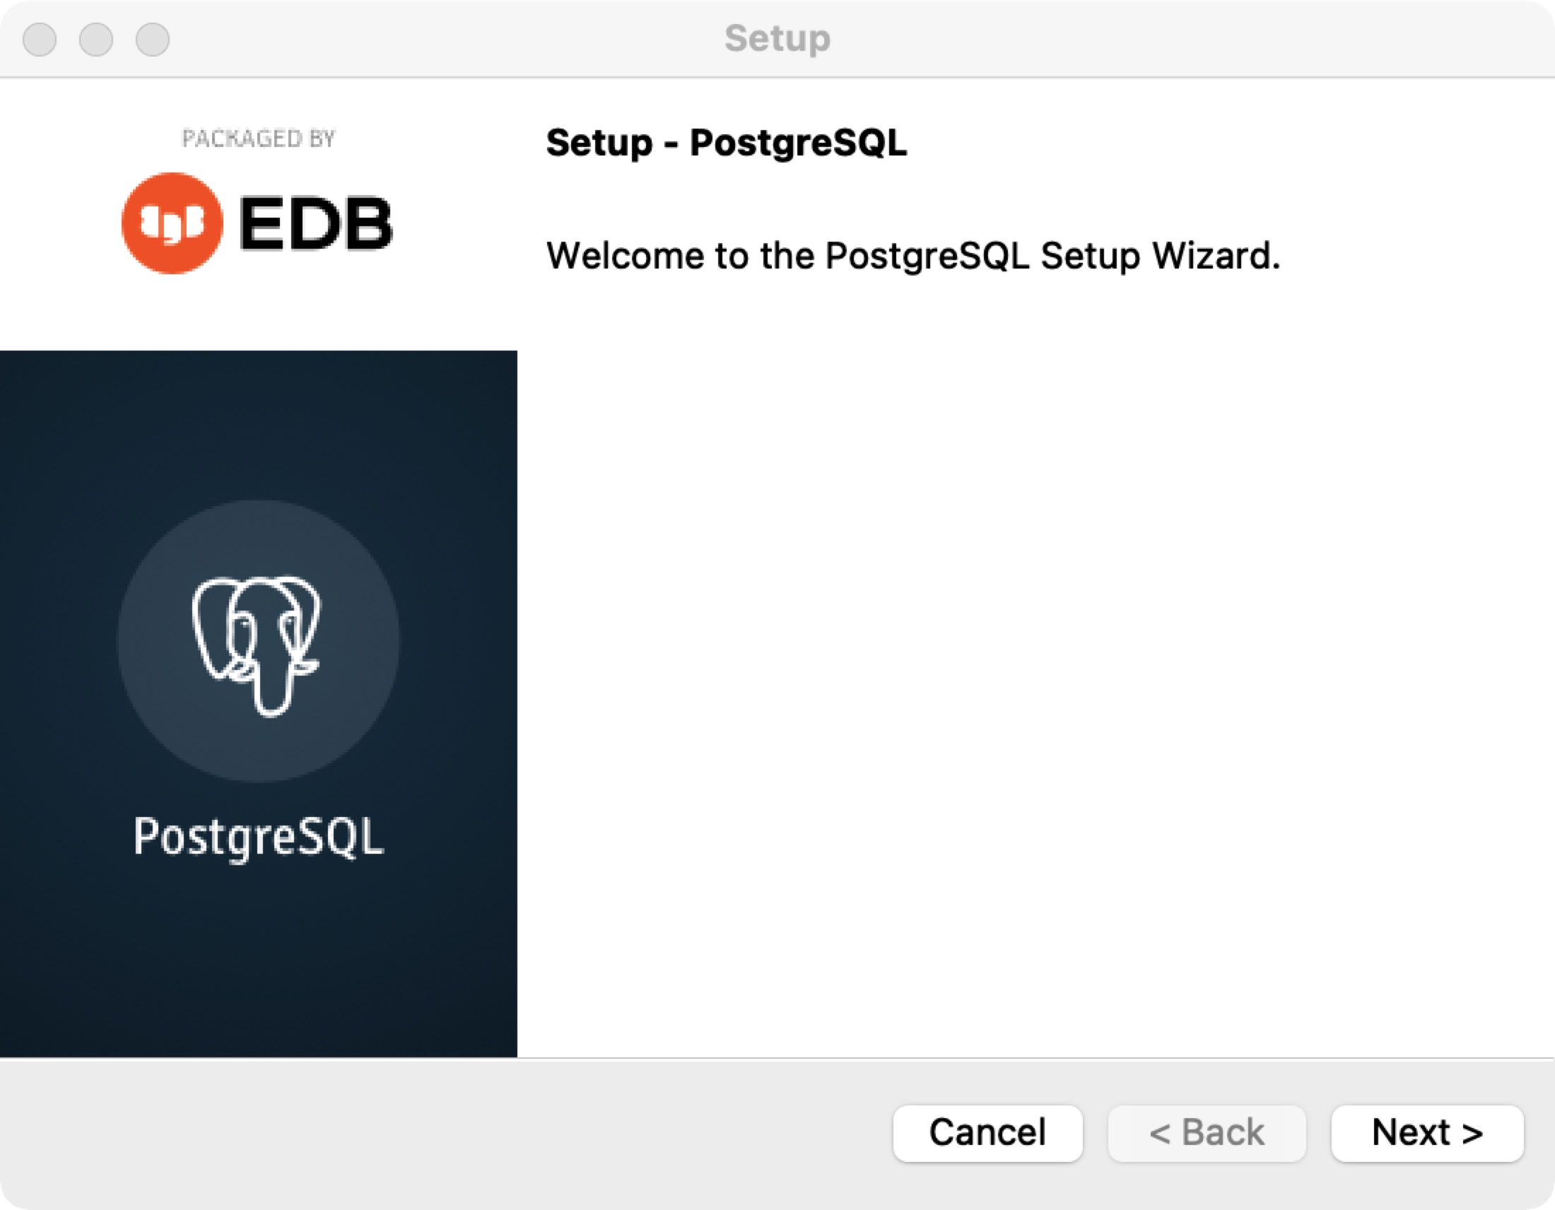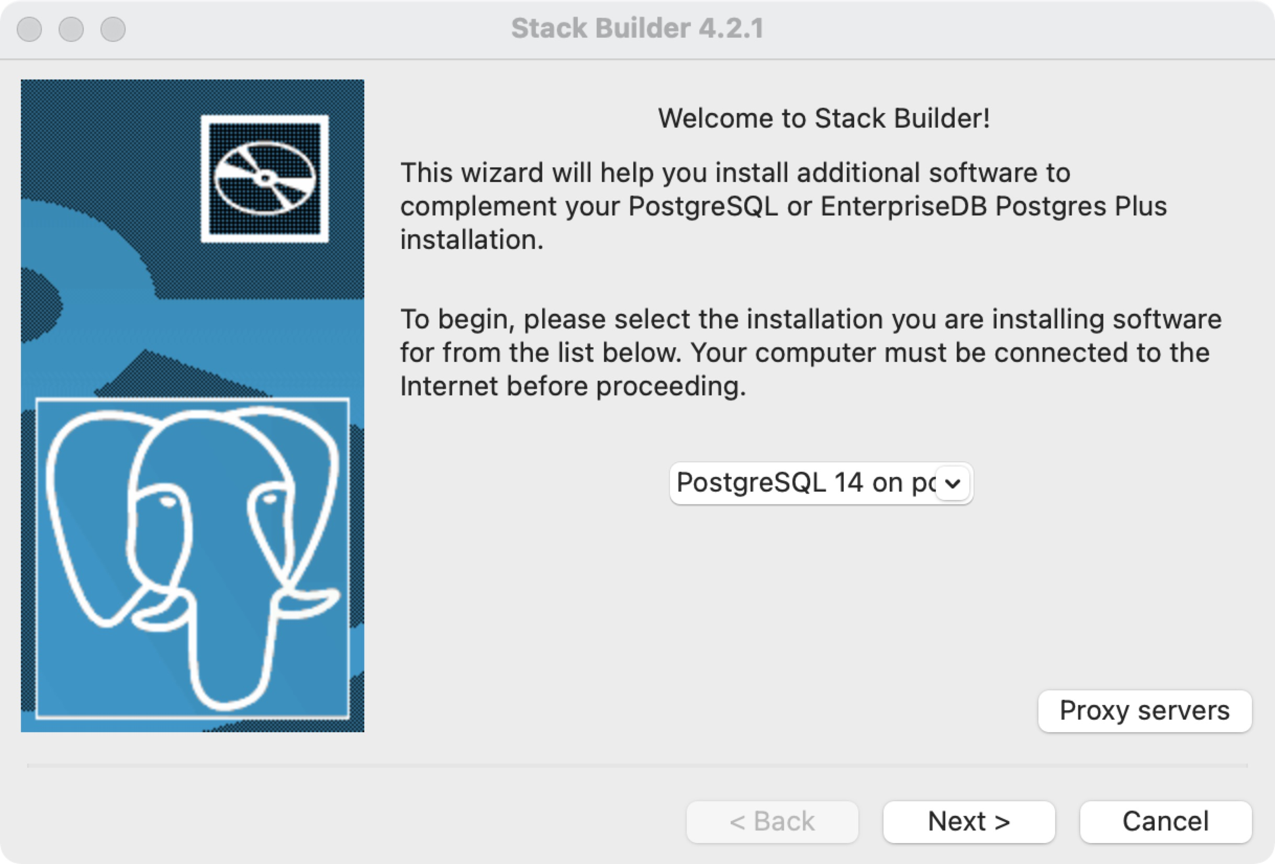
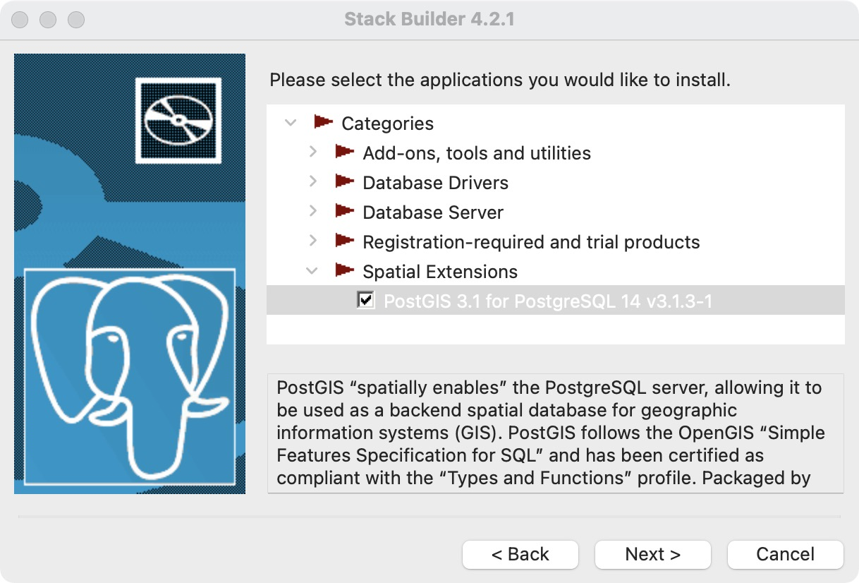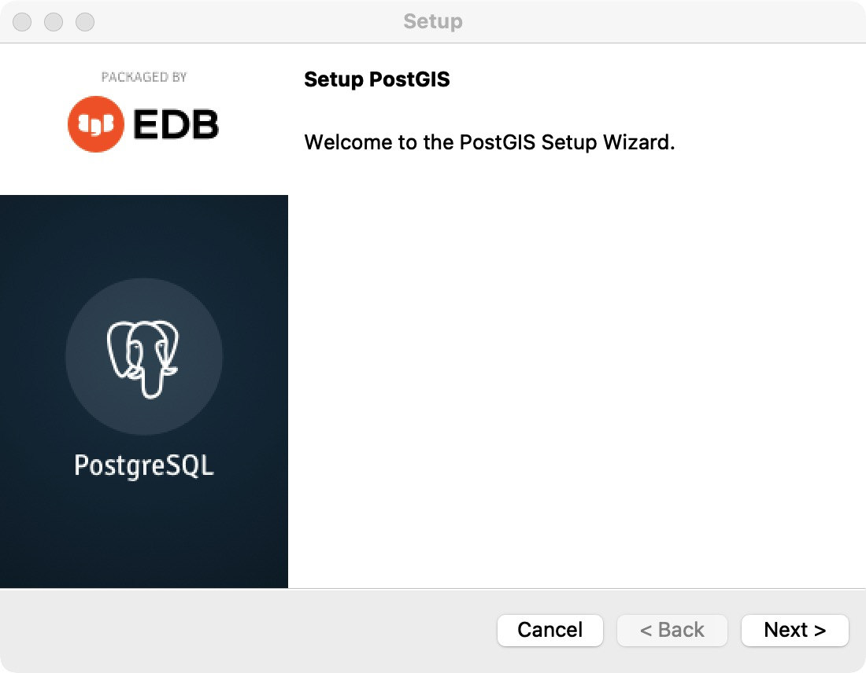

See http://sedona.incubator.apache.org/setup/install-python/
We provide sedona-python-adapter-3.0_2.12-1.1.1-incubating.jar and geotools-wrapper-1.1.0-25.2.jar
See https://wiki.openstreetmap.org/wiki/Main_Page
Also the name of your email address, e.g., if your email address is lin00786@umn.edu, your id would be lin00786
PostgreSQL downloads: https://www.postgresql.org/download/
https://postgis.net/install/
https://gdal.org/
See https://wiki.openstreetmap.org/wiki/Main_Page
See ST_Buffer for PostGIS here: https://postgis.net/docs/ST_Buffer.html
https://pandas.pydata.org/

