CSCI 5980/8980: Spatial Enabled Artificial Intelligence
Assignment 2 (10 points)
Due Date: 2022/03/08 11:59:00 CST

1. Overview of the Assignment
In this assignment, you will learn to use machine learning methods to support real-world spatial artificial intelligence tasks. You will implement the approach proposed in the paper “Mining Public Datasets for Modeling Intra-City PM2.5 Concentrations at a Fine Spatial Resolution” [Lin et al. 2017]. The approach aims to generate fine-grained air quality prediction over a region using sensor observations (PM_{2.5} concentrations) and geographic feature data. You will apply clustering, classification, and regression techniques to solve the problem. You can access the data on Google Drive.

2. Programming Requirements and Environment Settings
- You must use Python to implement all tasks.
- Programming Environment: Python 3.7 (you can use the same environment as Assignment 1)
- You need to download and use QGIS to visualize results.

3. Assignment Datasets
This assignment provides the following datasets [download]:
- Datasets of Purple Air sensor locations, named as county_sensor_locations_[train/test].csv
The Purple Air sensor location data contain the sensors in Los Angeles County (LA County), represented as sensor IDs, longitude, and latitude in WGS84. The sensors with missing observations are excluded from this assignment. We split the locations into train (60%) and test (40%) sets. You will use the train samples to build a model and generate prediction at test locations for quantitative evaluation.
- Datasets of Purple Air sensor observations, named as county_sensor_observations_[train/test].csv
The sensor observation data contain the observed PM_{2.5} concentrations (column “pm2.5”) at the sensors in LA County, reported hourly from January to February in 2022. We split the observations into training and testing sets based on the locations.
- One dataset of grid locations, named as county_grids.csv
You will generate the prediction of PM_{2.5} concentrations at grid locations in LA County (see Figure 1) for qualitative evaluation. Each row in the dataset represents a cell covering a region of 1,000 × 1,000 square meters, described by grid ID, longitude and latitude of the centroid of the cell, and the geometry of the cell (in the form of text).
- Datasets of geographic features, named as county_[sensor/grid]_geographic_features.csv
You will use the geographic features generated from OpenStreetMap to describe the surrounding environment of a location (see assignment 1). We have generated geographic features using the buffers from 100 meters to 3,000 meters with an interval of 100 meters. The datasets are available for the sensor locations (the geographic features for train and test locations are in the same file) and the grid locations.

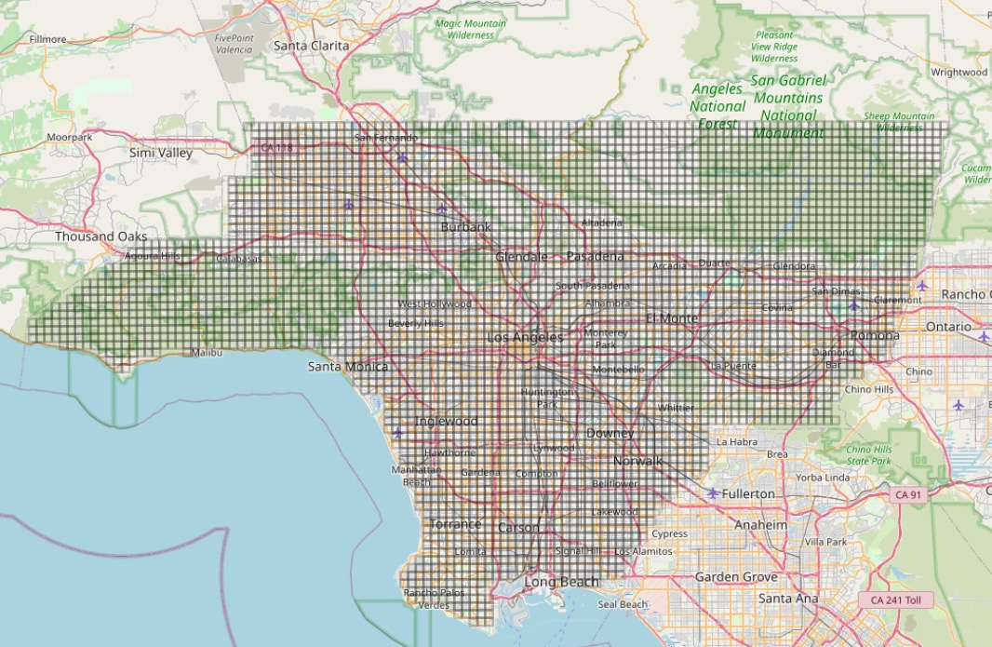
Figure 1: Grid locations (a total of 4234 cells) in LA County

4. Deliverables and Tasks
You need to turn in a zip file, named as [your_login_id]_assignment2.zip (all lowercase), e.g., lin00786_assignment2.zip, containing the following files:
- [REQUIRED] Code scripts: two Python script named as task1.py and task2.py
- [REQUIRED] A model file named as model.save
- [REQUIRED] Two result files named as test_prediction.csv and grid_prediction.csv
- [REQUIRED] A readme document in Word describing the results, named as readme.docx
- [OPTIONAL] You can include other Python scripts to support your programs (e.g., callable functions).

4.1. Task 1: Identifying Important Geographic Features (2pts)
In this task, you will write the code in task1.py to automatically identify important geographic features for predicting air quality from training samples. You can follow the paper or the steps below.
Step 1: Clustering Sensor Locations
In this step, the goal is to group sensors that have similar temporal patterns on PM_{2.5} concentrations. For example, locations near the highway would show higher PM_{2.5} concentrations during the daytime than those near parks. Thus, these locations can form into two clusters.
The paper uses K-means to cluster the available sensors based on the collected time series of PM_{2.5} concentrations, i.e., the observation at a time point forms one feature dimension. You can use the elbow point strategy to decide the number of clusters. Also, you can apply other clustering algorithms. Optionally, you can do dimension reduction on the time series first and then cluster the lower-dimensional representations. You need to report the number of clusters you are choosing and the clustering results in a dictionary format as {sensor ID: cluster label}.

Step 2: Constructing Geographic Abstraction Vectors
This step aims to convert geographic features (e.g., Table 1) to geographic abstraction vectors (e.g., Table 2). The features in the vectors are the distinct geographic features, represented as a combination of [Geo Feature, Feature Type, Buffer Size]. For example, in Table 1, there are seven distinct features (e.g., Highway_Pedestrain_500). Sensor A has values in five of the features, and sensor B has values in four of them. Table 2 shows the constructed vectors for sensor A and sensor B. If the location does not have a particular feature, the value will be 0. You need to report the number of features in the geographic abstraction vector.

Table 1: Geographic features
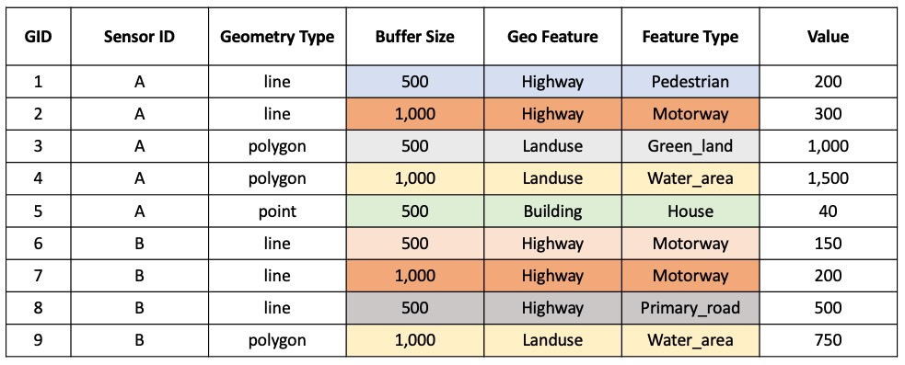

Table 2: Geographic abstraction vectors
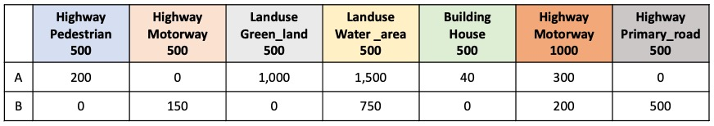

Step 3: Computing Feature Importance
In this step, our goal is to automatically identify which geographic features within what buffer size have the most impact on PM_{2.5} concentrations. The paper uses the grouped sensors as the label (the dependent variable) and their geographic abstractions as the predictor features to train a random forest classification model. You might need to preprocess the geographic abstraction vectors with normalization (e.g., min-max-scaler) before applying machine learning algorithms. Then you will extract feature importance from the random forest model. You need to report the top 20 features with the highest importance in a table (see the format below).
Geo Feature | Feature Type | Buffer Size | Importance (%)
highway | service | 2900 | 0.005234

Step 4: Saving Model
You will save your model to a file, including scaler for normalization and selected features (e.g., picking top 10% important features). You will load this model for the prediction. There is no restriction on what and how to save, but pickle file is recommended.

Execution Commands:
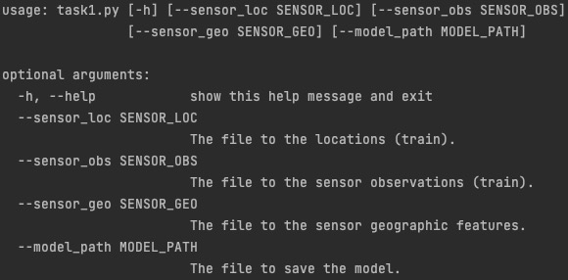

4.2. Task 2: Generating Predictions (3pts)
In this task, you will write the code in task2.py to generate predictions for given locations. The given locations can be test samples or grid locations. You can follow the paper or the steps below.

Step 1: Constructing Geo-Context
In this step, you need to construct geo-context for the observed sensor and given locations, respectively. The geo-context are the vectors containing the selected geographic features from the model in Task 1. These features replace the original geographic abstraction and become a description of the geographic environment around a location for predicting PM_{2.5} concentrations.

Step 2: Generating Predictions
To predict PM_{2.5} concatenation at a time point for a given location that does not have sensor, the paper trains a random forest regression model with the geo-context (as the predictors) and the PM_{2.5} concatenations (as the dependent variable) at that time from all available train sensors.
You need to generate predictions for the test locations (a total of 27) and grid locations (a total of 4234) at all time points (a total of 745). You need to save the predictions in CSV files (see the format below).
Table 3: Prediction file format for test samples
sensor_id | timestamp | prediction
1852 | 2022-01-01 00:00:00-08:00 | 29.51327

Table 4: Prediction file format for grid locations
grid_id | timestamp | prediction
1 | 2022-01-01 00:00:00-08:00 | 18.90042

Execution Commands:
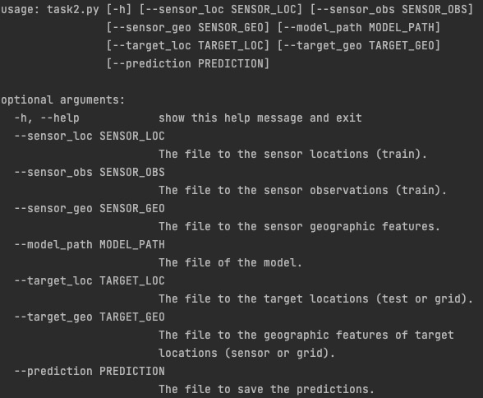

4.3. Task 3: Evaluation
In this task, you will write the code to evaluate your predictions quantitatively for test samples and quantitatively for grid locations.
For test locations, you will report the MSE and R2 scores by comparing the predictions to the ground truth (i.e., sensor observations for test locations). Specifically, you will need to (1) the overall MSE and R2 scores, and (2) the MSE and R2 scores at each hour (hour is from 0 to 23). For (2), you need to plot the trend of RMSE and R2 scores (y-axis) along the hours (x-axis).
For grid locations, you will use QGIS to visualize the predictions at a time (see the steps in Appendix). You will join the predictions with cell geometry on grid ID and save as a new file. You need to show the spatial visualization for the average PM_{2.5} predictions in the morning (6am to 9am), afternoon (4pm to 7pm), weekday (Monday to Friday), and weekend (Saturday and Sunday). You need to report the four screen shots and discuss the spatial pattern of the predictions in the README. Optionally, you can use the same color scale for the plots.

5. Grading criteria
- Your code should be runnable and be able to generate results correctly (that is, generating the models and predictions with the submitted Python scripts successfully) to receive full points on Task 4.1 and Task 4.2 (a total of 5 points).
- In the readme document, you should report the following things:
- The number of clusters and the cluster label for each sensor location (0.5pt)
- The total number of features in the geographic abstraction vector (0.5pt)
- The top 20 important features and their importance (1pt)
- Overall MSE and R2 on test samples and the plot showing hourly MSE and R2 scores (1pt)
- Four plots of fine-grained prediction results (screen shots) (1pt)
- Your findings and discussion on the selected features, MSE and R2 scores, and plots of fine-grained predictions in several sentences (no more than 300 words) (1pt)
c. You can put any external libraries that are necessary to execute your code or other instructions that can help TA run your assignment.

Appendix:
- Load OSM from XYZ Tiles
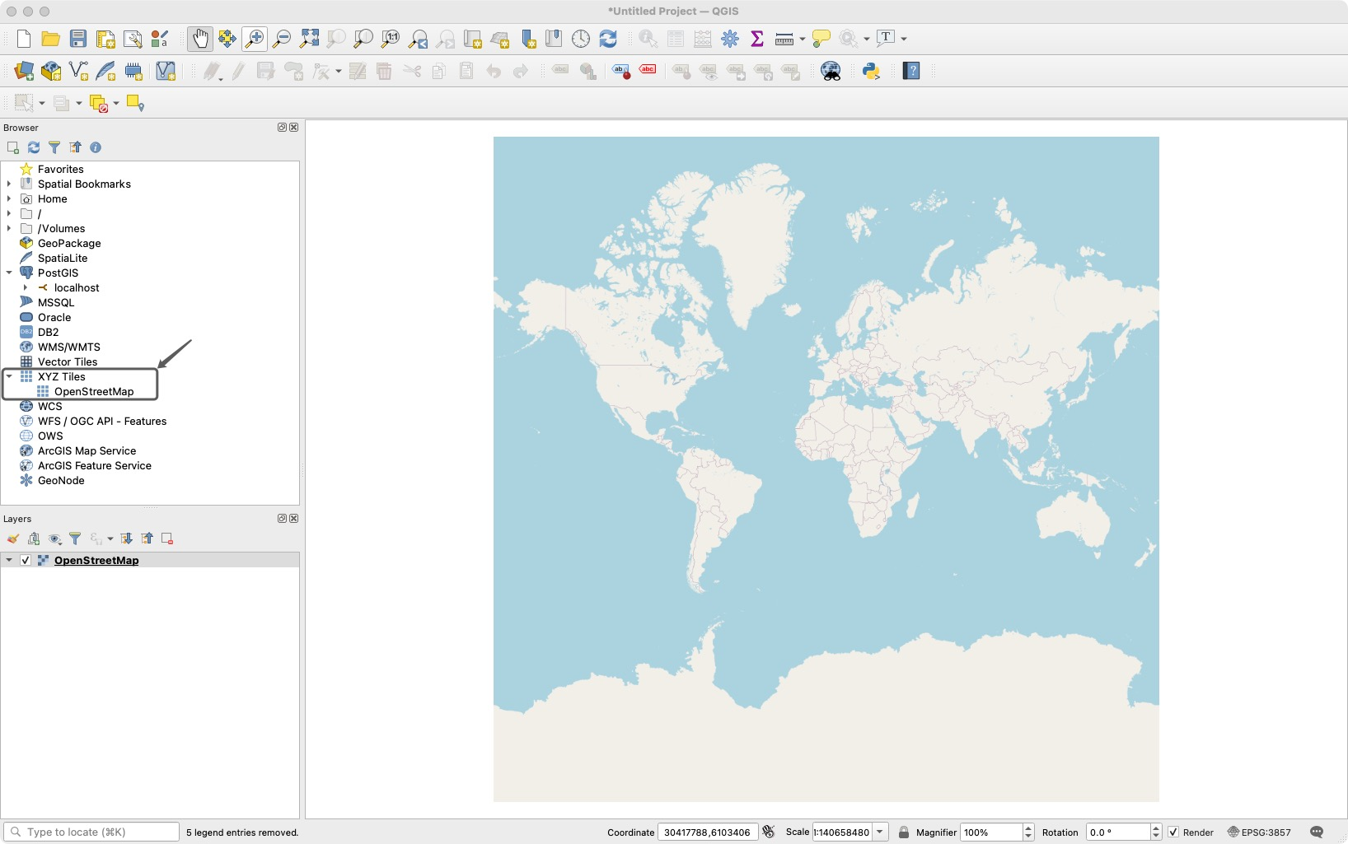

- Load predictions at a specific time point from “Layer” -> “Add Layer” -> “Add Delimited Text Layer” -> Add the prediction file -> Fill in Geometry Definition
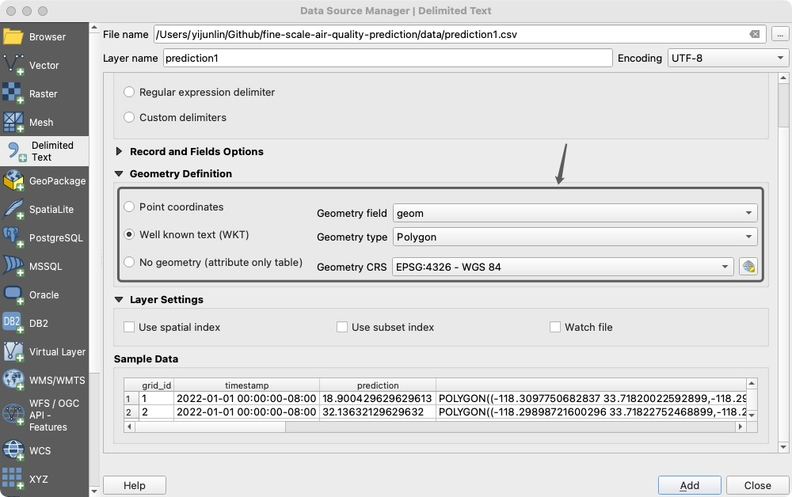

- Zoom to the prediction layer
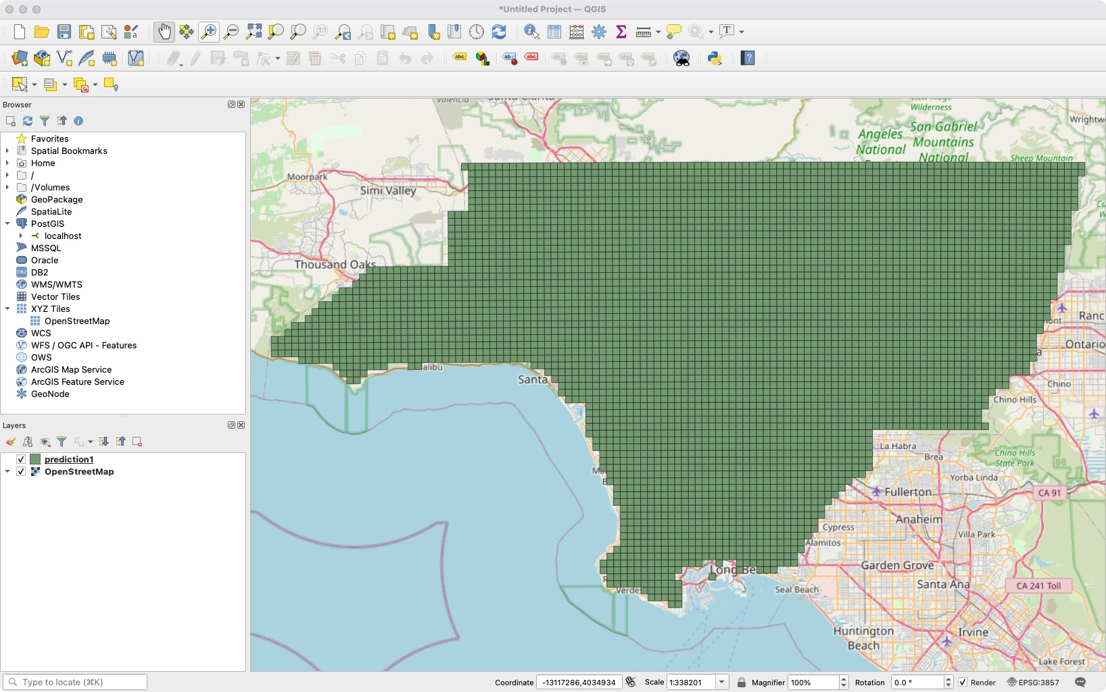

- Set the color for grid -> Layer Properties -> Choose style as “Graduated” -> Set Value from the table -> Set Color ramp as “Spectral” and “Invert Color Ramp” -> Set number of classes (the more classes the more detailed the visualization, you can add fake numbers to keep the same color scale for all plots) -> Set opacity to a proper number (50% - 70%)

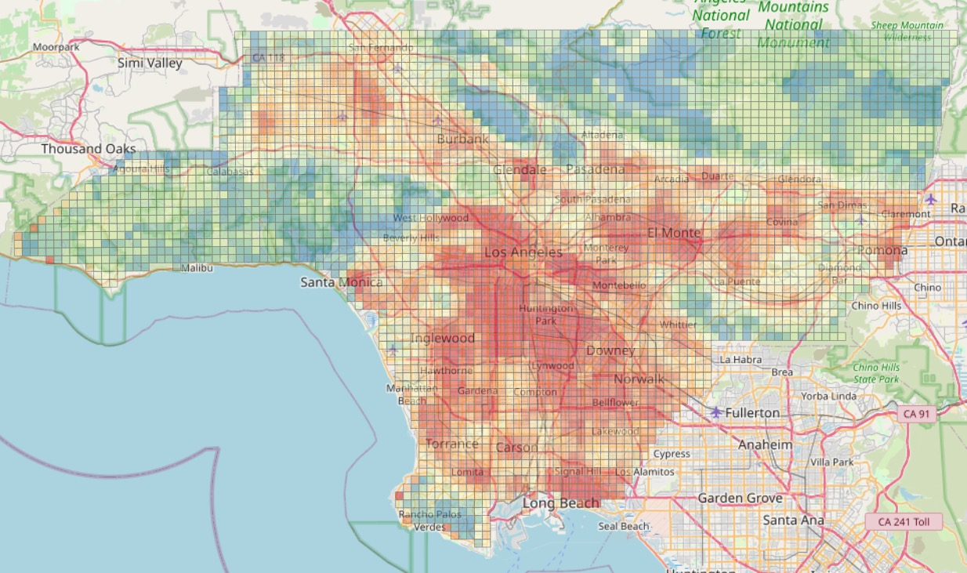
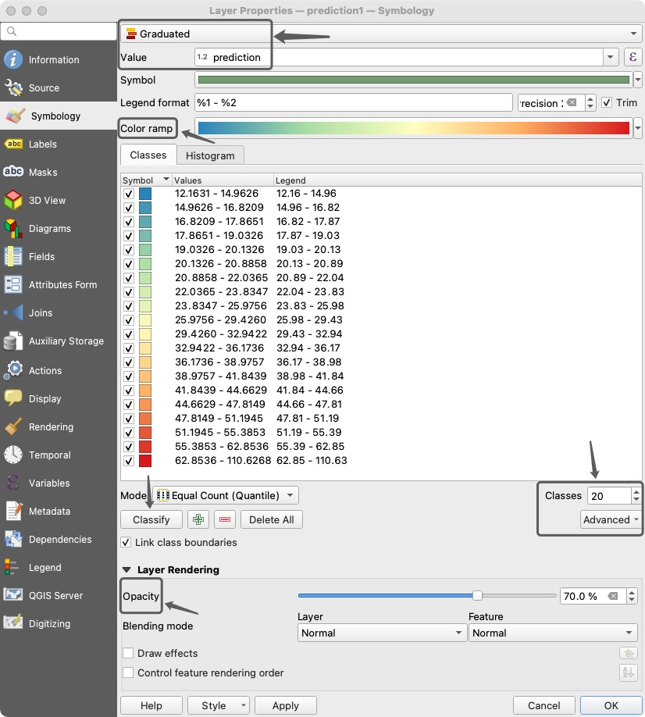

The name of your email address, e.g., if your email address is lin00786@umn.edu, your id would be lin00786

